Report from annual short-term field visit in collaboration between
FO Hordaland and TASWO Kilimanjaro 2019

Hosting organization: Tanzania Association of Social Workers, TASWO – Kilimanjaro Branch Sponsor: FO, Hordaland Branch
Submitted by: Svanhild Alver og Heidi Johannessen

FO Hordaland branch have had collaboration with Tanzania Association of Social Workers, TASWO, Kilimanjaro branch in Moshi since 2011. From 2015 FO Hordaland has given two members the opportunity to participate as field visitors in an organization chosen by TASWO once a year.

We felt privileged to be the two members going in 2019. We were visiting Moshi and TASWO from 29.08 – 07.09.2019.
From 2. - 6. September, we conducted field visit at Pamoja Tunaweza Boys and Girls Club (PTBGC) situated in Moshi, Tanzania.

The Journey and the introduction:
We traveled, from Norway to Moshi in Tanzania, together with 4 union representatives from FO Hordaland, heads of FO Hordaland og Sogn og Fjordane Grethe Kvist og Ann-Kristin Nygård, deputy Mohammed Medi and member Lene Serengeti, who were to meet with local TASWO representatives, among them Duncan Mgati, the head of social services in Moshi. This meant that we had an evening together with these and gained an expanded understanding of both international cooperation and the commitment to this.

We also got to meet Morgan Amani, a young and talented social worker who would be our supervisor during our stay. He was also an experience-consultant, with experience of being a street child and orphanage in Moshi. With this background, he, along with others, had initiated a local street boy project in Moshi. He told us about the project -how they work, their vision and so on. We were also given a great opportunity to ask questions. We were informed and got prepared for the coming week – and were even looking more forward to it!!

The first day we were shown around in the city by FO, the second day we had a guided tour with Morgan Amani to the foot of Kilimanjaro.

These two days were a good introduction to the project by giving us an understanding of context, we saw transitions from the dry landscape to the lush greenery, where they cultivated coffee, bananas, etc. We were told that the large plantations had been divided and given as smaller properties to local workers. We were told that the largest population in the area was the Chaga people, but that there were others, among them Masai. We got to see how the Chagas lived in ancient times and we got to experience the pride they had for their story.

We were asked to learn some phrases in Swahili, words that we greatly benefited from in contact with the young people we would later work with, most of whom spoke little English. -At this time, we knew little about facing a week of very hard and unfamiliar work

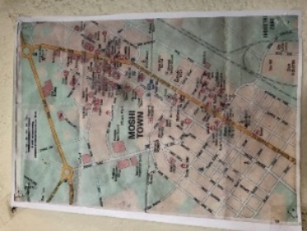
Moshi:
Figure 1 Map og Moshi
The city is a municipality and the capital of Kilimanjaro region in the north eastern Tanzania. The municipality has an estimated population of about 200 000 people.
Morgan Amani, our supervisor during our stay, told us that the city has about 600 street-connected children and young ones.

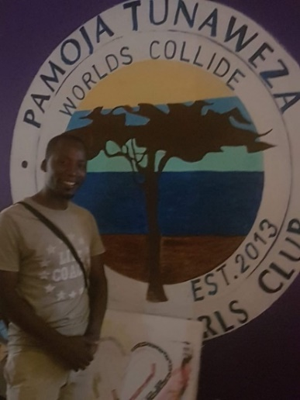
About Pamoja Tunaweza Boys and Girls club:
Figure 2 The head of PamojaTunawesa Boys and Girls Club, Morgan Amani
It is a collaboration between the original Hard Life Art Club, One Ndoto and Worlds Collide, and was opened December 2013.
Pamoja Tunaweza Boys and Girls Club (PTBGC) was born out of the desire to provide education and employment opportunities to the most vulnerable youth in the Kilimanjaro region of Tanzania. This group of youth is called 'the lost boys'; street-connected male youth over the age of 16. These young men have a basic education and spend their days on the streets, collecting rubbish and metals to sell in order to feed themselves. At night, some can return home while others find a quiet spot under a bridge and in a doorway to sleep, often in an empty rice bag. Drugs, alcohol, violence and abuse are abundant. PTBGC hope to make a significant impact on this cycle of poverty by focusing on these youths whom are so often left out of national and international aid program.

In Swahili, Pamoja Tunaweza means: "together we can".
They believe: " together we can dream that when worlds collide, anything is possible".
Morgan Amani is the head of the center. He was also our daily contact and our supervisor during our stay. There are also other leaders Denis, David, Valerian, Simba and Richie.

Vision:
To empower vulnerable and at-risk youth to reach their potential and become productive, self-sustaining and responsible members of the community.

Values:
- Provide a safe and healthy environment for the children to learn and grow
- Provide inspiring community role models
- Offer life enhancing programs and character development experiences
- Offer hope and opportunity

(About PTBGC; from their FB-page.)

Our experience:
In the morning:
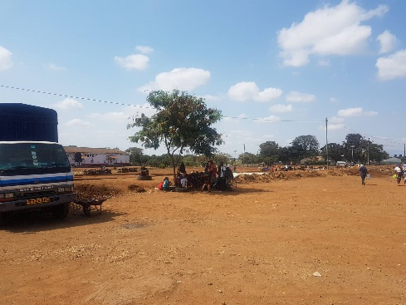
-Morgan picked us up at the hotel every morning. We walked through the town and into the marked area, and on the other side there was an open space with one tree that gave shadow. There were two small benches and some old car-decks, these items were moved around the tree so that we during the day could take effort of the limited shadow from the tree. This was where they had their gathering place for their morning activities. They used to be ten to twenty young ones there. The activities were such as:
Figure 3 The gathering place
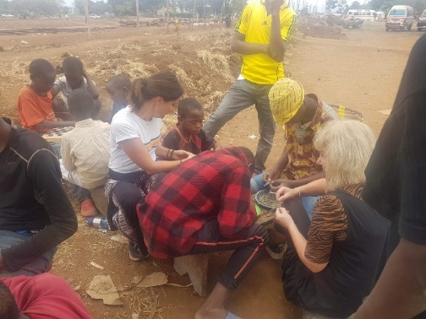
-making bracelets
Figure 4 Hard work- pearling
-activities like spike ball, playing games
- they had lessons teaching the children social skills, first aid, how to make good decisions for themselves, for example say no to drugs.
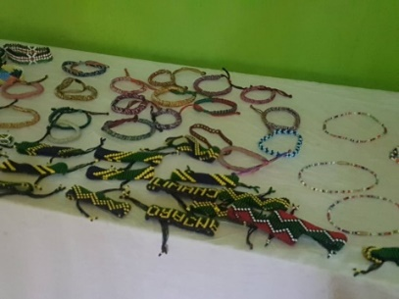
Figure 5 What they, -and we for a few days, made

For the boys making bracelets was a way to earn some money to get food for us it was an opportunity for contact and relationship with the boys.

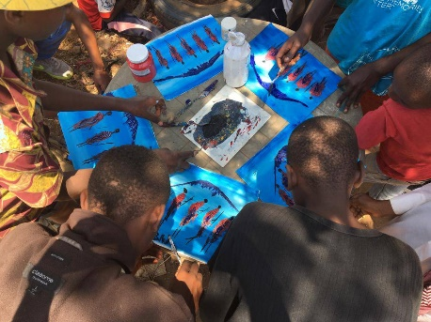
They also had a lesson in painting techniques for a small group one day. Morgan told us that they had this kind of lessons once a week. They had to choose who could benefit and enjoy painting. This also had to do with the cost of the equipment.
Figure 6 A lesson in painting

After lunchbreak:
-the days continued at the sentre.
Figure 7 Dennis in action, making drinking glasses out of old bottles
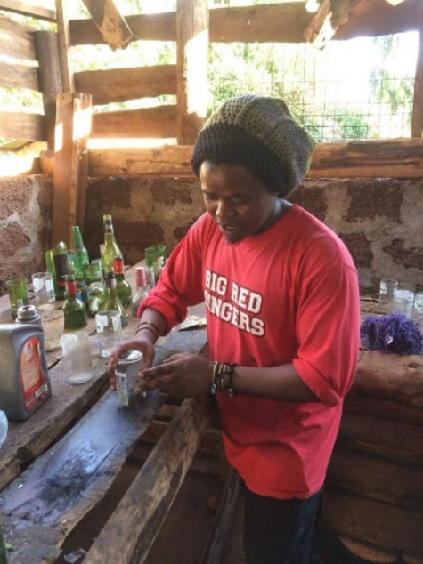
The older youth are working together with leaders also during daytime.
We were shown around the sentre and taught by some of the leaders and youths what they are producing. This is trademark products and they also research and execute new designs here.
-They are selling their products in a small shop in Moshi, and they have their own shop and cooperate with “Mama Africa”
They made more bracelets, some paintings and they made very nice glasses from old bottles.

Outreach night time:
Once a week or more often, some of the project staff went on a nightly walk to check young people sleeping on the streets or wandering around at night. We joined once. This to ensure security, check that they were ok and were not bothered. Here we also had a little chat with prostitutes and others.

The young ones:
They were a different gathering of young people and children who showed up every morning. Most of them were fifteen to sixteen years of age, but also some older. There were also some in school uniform, before or after school, they did not pearl, but talked to familiar and watched the work. Occasionally there were some small ones too, these were curious and had parents working in the large food market close by.

Sometimes the new and young children came, who look lost and did not go home in the afternoon. These were included and talked to, and during the afternoon they were placed in a kind of child welfare institution, while at the same time some social workers trying to establish contact with their families to try to get them reunited, if possible - there was a separate collaborative project working on this, organized by Simba Nixon Aqulin/Kipepeo

Their working methodologies:
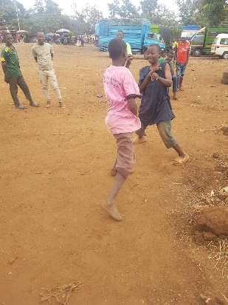
It's hard to say that they had a clear methodology, but they worked according to well-known principles of social work. This by working in practice to promote social change and development, social cohesion, empowerment and liberation of people. They were concerned with social justice, human rights, collective responsibility and respect for differences.
Figure 8 Role playing a street fight between two young ones, where a third boy was coming in and explain to them why they should not fight.

The methodological approach must be said to be eclectic by using elements from a variety of methods. The most important thing was that they were role models, young men who, despite a difficult background, had managed to avoid traps such as passivity and the use of alcohol and drugs. Furthermore, they met the youth on their own terms, they were in close contact with the youth, were humble to the youth's experiences and showed generosity, care and kindness in meeting them. In the "game" they used role-playing games, for example; what do you say when someone wants you to participate in activities that you yourself do not want to participate in, like activities related to drugs and alcohol. They also talked to the youths about how to realize their own dreams, guided and encouraged them.

The work also had common features with methodology used by outlets, such as organizing activities, most often without obligation, and working with outreach with the goal of establishing contact with young people who roamed or vagabonded around day and night time.

Finally, they also went on home visits, where they followed up boys who, for various reasons, were unable to participate in day-to-day activities. These visits could be about practical help, financial help and guidance.

Football
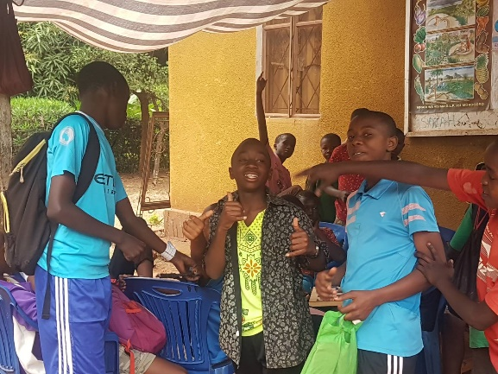
They have founded a local Sports-club, Pamoja Sports Club. The club consist with more than 80 participants/ children from the community and the streets of Moshi. With soccer and other sports, they want to break down barriers between the locals and the street-connected children.
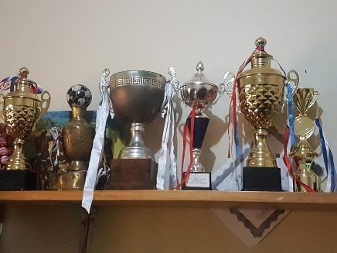
Their belief is that using soccer and other sports, the children can make the best union among themselves, whereby they will love one another and shaping their behaviour and even educate the community not to perceive them as illegal people.
Figure 9 Preparing for a football match
Figure 10 What they have achieved

Girls
There were no girls in the project, even though they had initially been part of the target group. We asked about this, and were told that the girls were not vagabonded, they were often kept as housekeepers until they could marry or establish themselves. Some girls also ended up in prostitution.

Sharing experiences and knowledge/ exchange experiences:
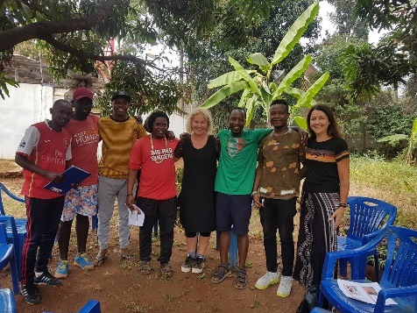
We were told before we left, that we should prepare a lecture to be presented for the co-workers in the project. We were also told that they had limited tools for us to give the presentation om screens or projectors, so we brought paper as well as a computer. So, what we did was sitting in plastic chairs, still in the shadow of a tree, and giving our presentation. We talked about the legal rights of the child as it is presented in the Child Welfare Act, the importance of the child`s participation and we presented some tools/ methods to help us to do this in a good and efficient way.
Table 1 The lecture
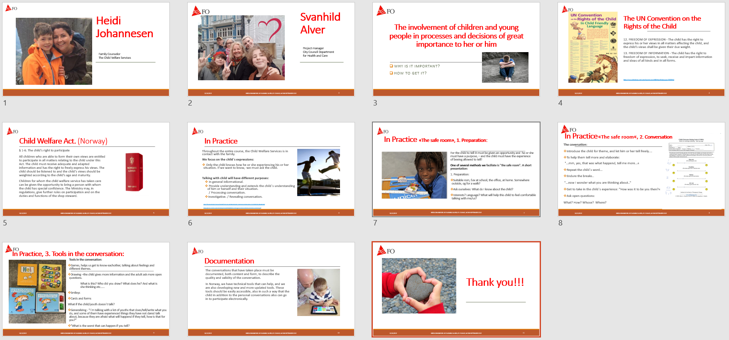
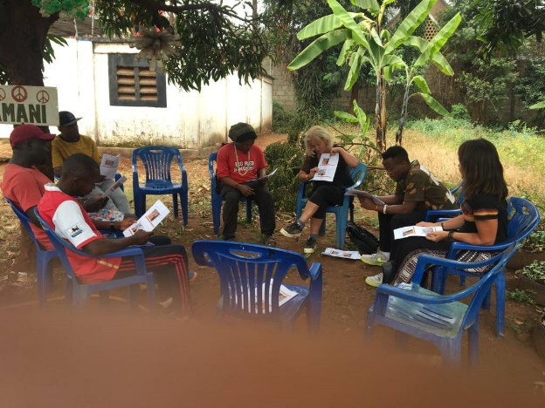
We got questions, reflections and discussions.

Asante sana -thank you!
We want to thank FO Hordaland, TASWO Kilimanjaro and Pamoja Tunaweza Boys and Girls Club for the valuable opportunity for insight and experience of how the core of social work is independent of cultural frames and understanding.
A child is a child anyway – they all need real love not fake.

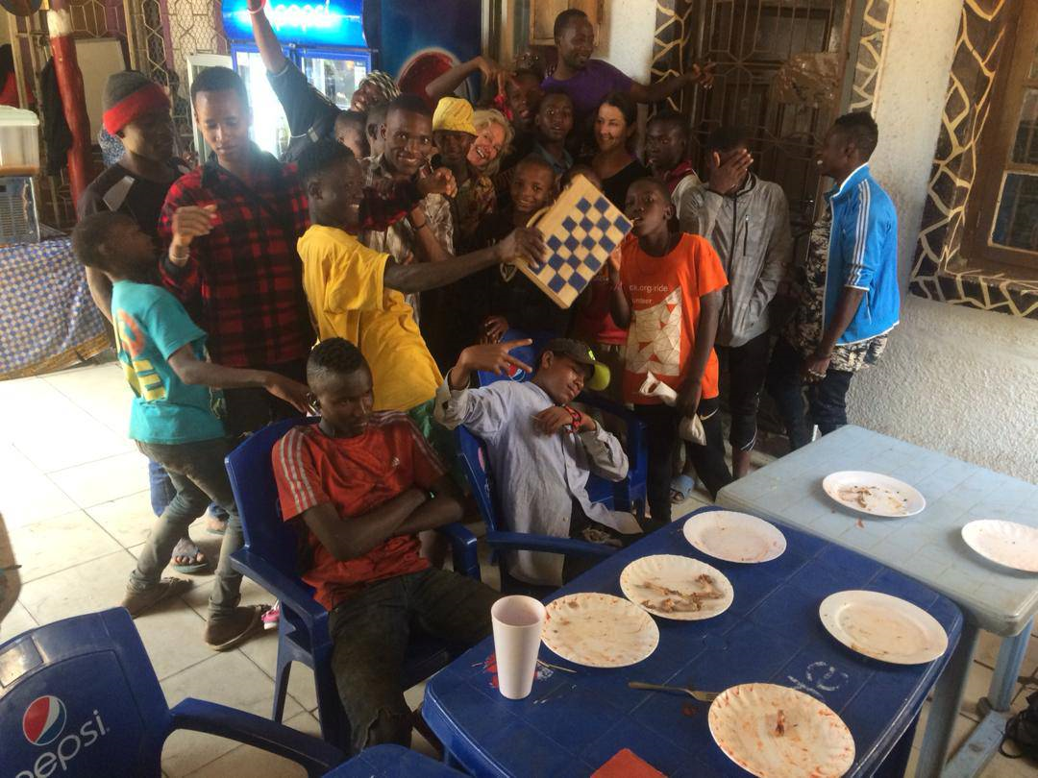
Table 2 Siste dag med "gjengen" - finn to feil ;)

